INTRODUCTION TO INFORMATION TECHNOLOGY

***Analysis***

The local animal shelter is asking for a low cost, programmable automated pet feeder.

**Product requirements**

* Low cost
  + To make it low cost this system will use a rudimentary Arduino system made of servo motor, weight sensors, led lights, IR sensor, RTC real time clock, and alarms/buzzers. This excluding the case of the pet feeder (pet food, bowls, etc), with the materials from the table below the system should cost for one system would be $42.41

|  |  |
| --- | --- |
| part | price |
| Arduino | $11.10 |
| Weight sensor | $3.95 |
| Buzzer/alarm | $4.99 |
| RTC | $5.44 |
| light | $3.25 |
| servo motor | $11.95 |
| IR sensor | $1.73 |
| total | $42.41 |

* Programmable
  + The use of an Arduino makes the system programmable and adaptable to changing situations. You can change the time of feed or even the conditions of which the staff are alerted by the feeding system. Arduino is easy to use and cheap to replace if it breaks
* Automated pet feeder
  + The Arduino system will make it automated
* Dispense food for cats and dogs at scheduled times.
  + The system will need to be created into two separate areas or be replicated for two rooms. There might also need to be slight variation how much the server rotates to release the food due to size variations in each animal’s food.
  + The system will have two set times for food dispensing. At 8am and at 6pm
* Monitor whether food has been consumed or the amount of food that has been consumed.
  + The system will do this by weighing the food once it dispenses then weighing it again after 10 minutes. If the weight has changed the system will take note by how much and store that information for someone to access and take not of if needed.
  + If the weight hasn’t changed the system will alert the staff.
* Alert staff if there’s an issue (e.g., no food dispensed, food not eaten).
  + This will be specified in the code using the weight sensor at several points during the task.

**Assumptions/limitations**

* Limited memory
  + This could be an issue, but the Arduino could just be programmed to wipe the memory every 2 weeks.
* Different pet food types
  + Cats and dogs have different food types. Cats do usually eat wet food over dry but that’s an entirely different problem. The pebble size difference between cat and dog dry food could cause an issue. This would be fixed by adjusting the angle the servo is rotated and how long it is. Testing would be done to survey the time and angle and how much food is released to get the desired amount.

**Sketch**

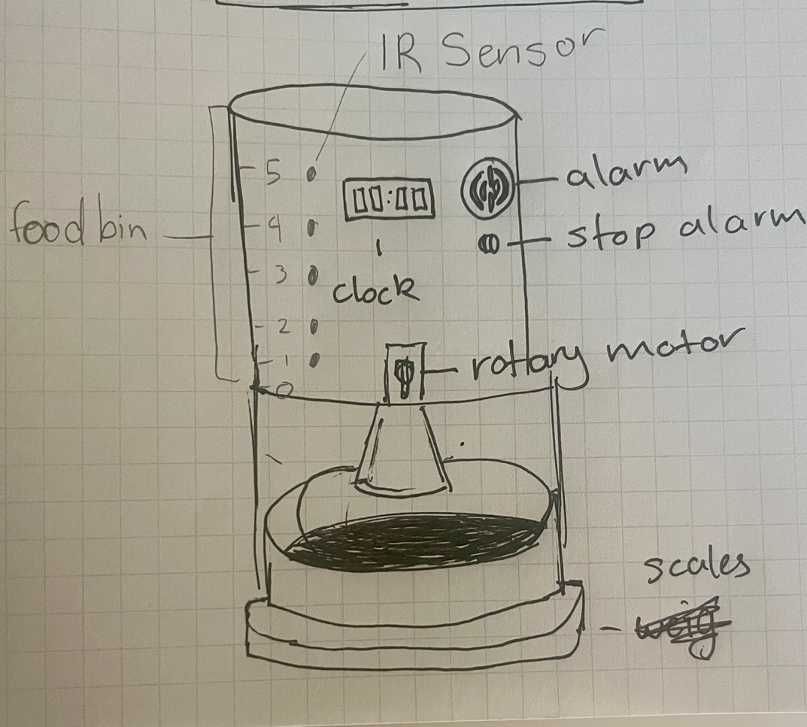

**Organise and Describe the Data**

|  |  |  |  |  |
| --- | --- | --- | --- | --- |
| Type | Name | Description | Sample values | Operational constraints |
| input | RTC | Tracks current time to trigger scheduled feedings | 08:00  18:00 | Must be synchronised and support 24h format |
| input | Weight sensor | Measures food weight in bowl before and after feeding | 0g, 200g, 50g | Accuracy ±5g used to detect dispensing and consumption |
| input | Food level sensor | Detects if food is available in the food bin | Level 1, level 5 | Must be checked before dispensing. Triggers refill alert |
| Output | Servo motor control | Rotates to dispense food | Rotate 90º, rotate 180º | Rotation angle based in portion size |
| Output | Alert system | Sends notification if issue detected | Led ON, buzzer, message sent | Accidently triggered |
| Output | Feeding log | Records timestamps and status of each feeding | 08:00 success, 08:00 alert | Limited storage |

**Plan the Solution (Design the Algorithm)**

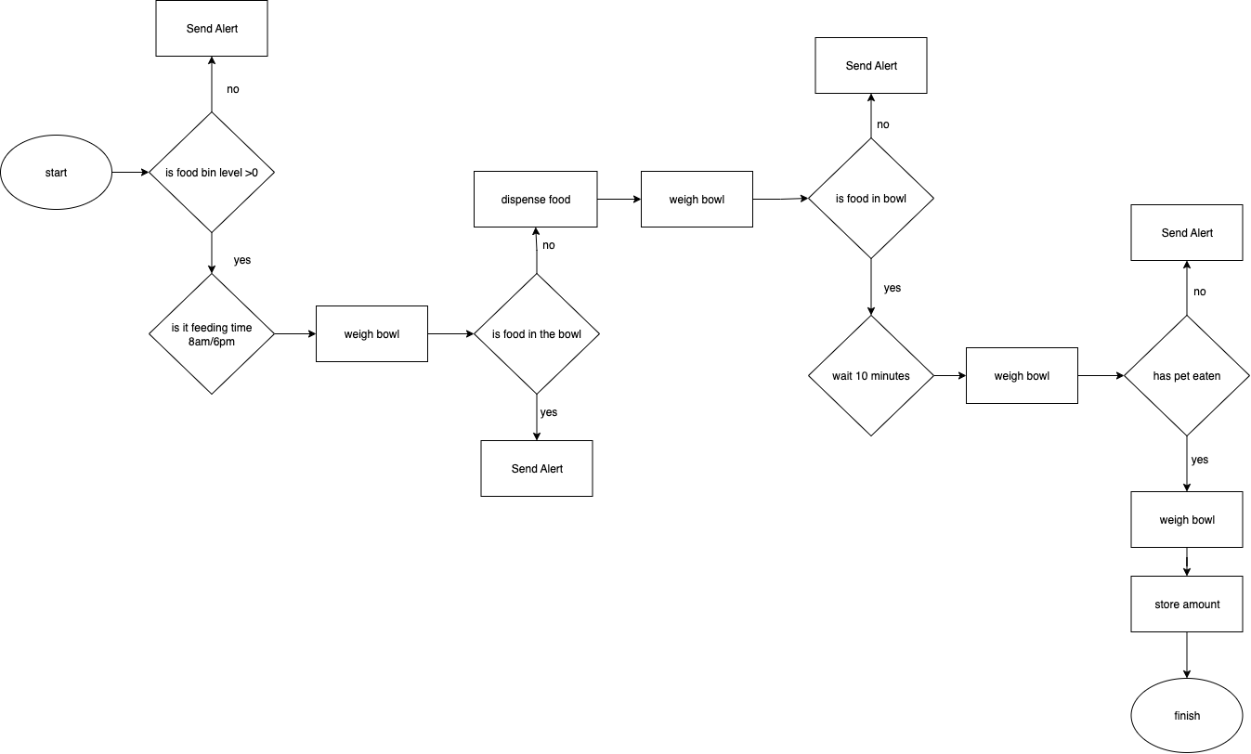

I asked copilot to improve this flowchart, and this is what I got

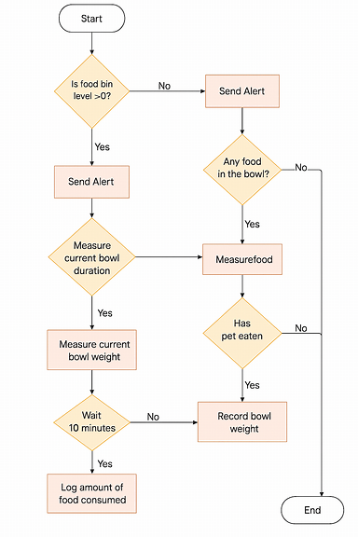

**Implement the Solution (Word Coding)**

Dispense food =

Roatate servo 90º clockwise

Wait 4 seconds

Rotate servo 90º anticlockwise

Send alert =

Alarm ON

Is time 8am/6pm

If yes, then

Weigh bowl

If weight = 0 then

Dispense food

Weight food

If weight = 0 then

Send alert

Else

Send alert

Wait 10 minutes

Weight bowl

If weight = >0 then

Send alert

Else finish

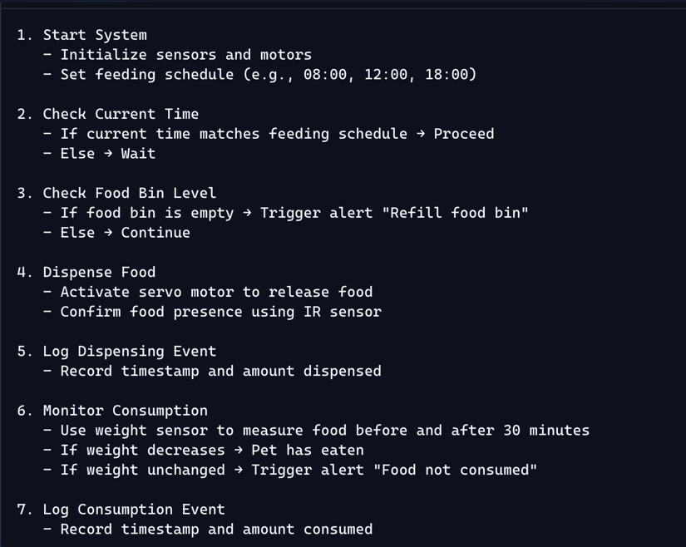I asked copilot how I could improve this, and this is what it gave me.

**Step 5: Test and Refine the Solution (Debug and Verify)**

**Test scenarios and outputs**

|  |  |  |  |  |  |  |
| --- | --- | --- | --- | --- | --- | --- |
| scenario | Food bin level | behaviour | Food dispensed | Pet ate | Expected outcome | Match? |
| Pet eats as expected | 5 | eats | yes | yes | Food dispensed, pet eats | yes |
| Pet does not eat | 5 | ignores | yes | no | Food dispensed, pet ignores | yes |
| Food bin is empty | 0 | eats | no | no | No food dispensed, alert triggered | yes |

**Discussion of logic**

* The system correctly prevents dispensing when the food bin is empty
* Accurately tracks whether pet eat based on previous behaviour and food availability
* alerts can be triggered based on the combination of sensor feedback and expected behaviour

**Suggested Refinements**

* behaviour logging
  + the system is able to record pet behaviour over time to detect patterns
* low food warning
  + allow a trigger to warn when the food bin is low not just when it is empty

**AI agent integration**

I used this for the word code and flow chart parts of my analysis

Reflection

I asked copilot to help me with the flowchart. Personally, I think my flowchart makes more sense and is easier to follow than the one generated. It misunderstood the line of logic to the point that in its flow chart and the decision block that asks whether the food bin is above 0. Both logic paths lead to sending an alert which doesn’t make sense. I then asked copilot to help me write the word code to the assignment. It understood the prompt a lot better and was able to write a clearer and more comprehensive response than I did (which was just trying to write it in barley comprehensible python).

So in one case copilot didn’t help as it misunderstood the line of logic with the flowchart. Reinforcing how important it is to question what you get from generative AI software as it has a habit of lying. On the other hand, it is capable of writing clear, consise responses better than you would yourself. It’s helpful in understanding how to better understand and respond to a question if you yourself and unsure of how to.